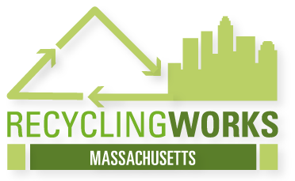
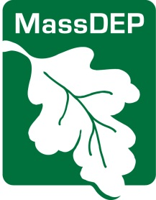
Massachusetts WasteWise Registration
The Massachusetts WasteWise Program offers tools and resources that help your business reduce costs on waste disposal and improve your environmental impact. There is no fee for WasteWise membership, and any organization may join. Your information will not be shared with any third-party and messages will be limited to information about the RecyclingWorks in MA program. Registration will provide you access to:
- Twice yearly forums on waste reduction and recycling
- Network with other WasteWise member organizations
- Use the Massachusetts WasteWise logo to promote environmental efforts
- Receive technical assistance to implement its WasteWise strategies
- Receive a monthly newsletter from RecyclingWorks in MA

Registration Information
Organization Name: _______________________________________________________
Industry: _________________________________________________ _______________
Address: __________________________ ______ ___________________________
City: _________________ ____________ State: MA Zip Code: ______________

Number of Employees: __________ Website URL:
How did you hear about WasteWise? _________________________________________

Contact Name: ___________________________________________________________
Title: ___________________________________________________________________
E-mail:_____________________ Phone Number:

Completing this form enters you in the Massachusetts WasteWise program only. Registration for the full, US EPA WasteWise program can be completed at: http://www.epa.gov/epawaste/conserve/smm/wastewise/index.htm. This will also register your business in the Massachusetts program.

